**1. INTRODUCTION**

**1.1 Scope of the work**

E-learning technology is paperless and global technology. In the early days,computer mediated communication through electronic mails, teleconferences and growing use of internet. But some students want degrees and courses which are apparently not available in their countries.Then e-learning becomes the suitable technology for those who wants to learn different courses and technology worldwide. The e-learning technology can be physical, local and uniform.By using e-learning students can improve their knowledge and can achieve their goals and tasks easily.

The project aims at improving the efficiency in the online education and reduces the complexities involved to the maximum possible extent.Home-schooled students, part-time workers, college/school going students, people who want to restart their career, if they want to do some courses outside their daily routine or curriculum, they need flexible hours to study. Online education is receiving a lot of attention these days due to flexibility of learning hours and the huge content of information available. This website can be used by parents, students and mentors. It aims at making online education flexible. So this system uses several programming and database techniques to elucidate the work involved in this process. As this is a matter of security, the system has been carefully verified and validated in order to satisfy it.

The system provides an online interface to the parent and teacher where they can view Information about student’s performance.It provides a communication platform between the teacher, parent, student and the administrator.

**1.2 Usage Scenarios**

**2. REQUIREMENT ANALYSIS**

**2.1 Functional Requirements**

The application provides the following functionalities-

**2.1.1 Admin Functionalities:**

* Login to his session
* View the statistics about the courses available
* Review the performance of registered students
* View the feedback given by parents and students
* Add or remove students
* Logout from his session

2.1.2 Mentor Functionalities:

* Login to his session
* Add lecture videos, study material and notes
* Add assignments
* View submitted assignments and evaluate them
* View the progress of each student
* Interact with students to solve their queries
* Contact the student’s parent
* Submit feedback
* Logout from his sesion

2.1.3 Parent functionalities:

* Login to his session
* Contact mentor
* View the profile of the ward
* Submit feedback
* Logout from his sesion

2.1.4 Student Functionalities:

* Login to his session
* View his profile
* Register for courses
* Opt out from courses
* Contact mentor to resolve queries
* Solve and submit assignments
* Engage in the discussion forums
* Submit feedback
* Logout from his sesion

**2.2 Non-Functional Requirements**

The following are the non-functional requirements in our project:

## **2.2.1 Performance Requirements:**

## Time taken for importing files and publishing the multimedia presentation should be minimum.

## The video quality should be clear and good .The audio could be heard well. The video and audio of lectures should be synchronized well.

## Responses to queries shall take no longer than 3 milliseconds to load onto the screen after the user submits the query for any user.

## The system shall display confirmation messages to users within 4 milliseconds after the user submits information to the system.

## The system should generate policy with an accuracy of 99%.

## **2.2.2 Safety Requirements**

* This requirement does not apply for our software as this system cannot pose a threat in any way.But again,reliable Internet is the backbone of the software so for the broadcasting of the video needs sufficient and uninterrupted internet connection.
* Also,power is a significant feature and the power supply should be always taken care of. An uninterrupted power supply is always recommended.

**2.2.3 Security Requirements:**

## As all the operations are to be done within a single system security is not an issue for this software.

## The files generated by the user are only accessible by the admin and application should store these files in MySQL database and must not share them. The policy framework should be accessible only by teachers.

## Administrators of the system will have full database administration rights and tutors/faculties may have access to a copy of parts of the VCS database, for editing purposes.

## Also this can be taken care by the login credentials provided to the user,admin and faculties through which the intruders can not easily cause a threat to the system.

## **2.2.4 Reliability**

## The system always has something to function and always pop up error messages in case of component failures if any.

**2.2.5 Availability**

* All the information that the user requires will be readily available and accessible. The application is also independent of the user’s location. The application will be available to the users anytime they wish to use it irrespective of the time and location provided that they have a good internet connection and screen.

**2.2.6 Usability**

* The application has a very simple and user friendly user interface. Any new user can easily use the application. Every screen has self-explanatory buttons and explanations that avoids any confusion for the user.The layout of the user interface is consistent throughout the application.The application supports English language.

**2.2.7 Documentation:**

* Software Requirements Specification is provided for the users as well as the developers and System Design Description is provided for the developers and the maintenance engineers.

**2.3 Use Case Scenarios**

ArgoUML software has been used for constructing Use-Case diagrams:

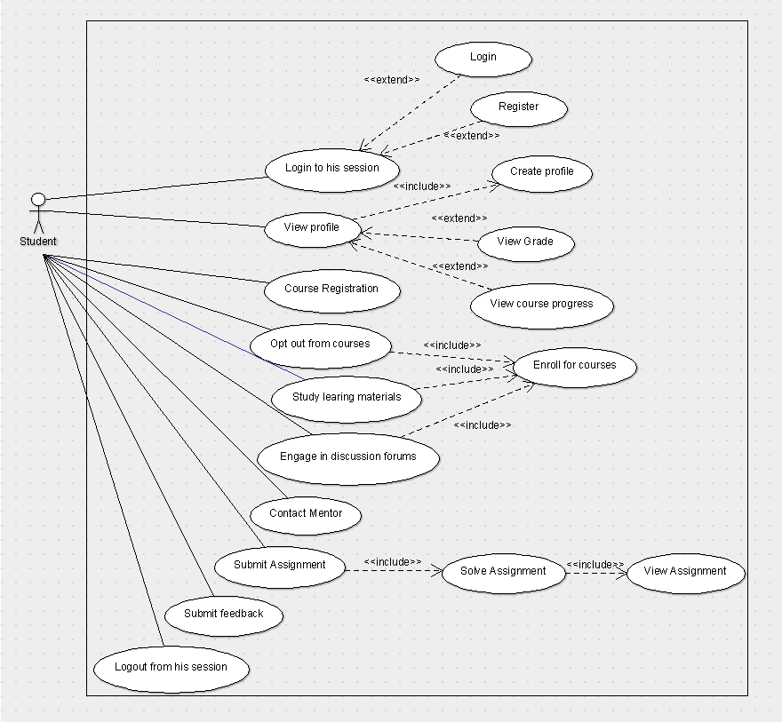

**Figure 1 : Use case diagram for Student module**

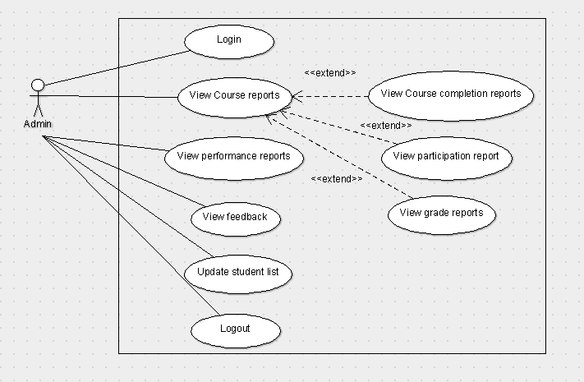

**Figure 2: Use case diagram for Admin module**

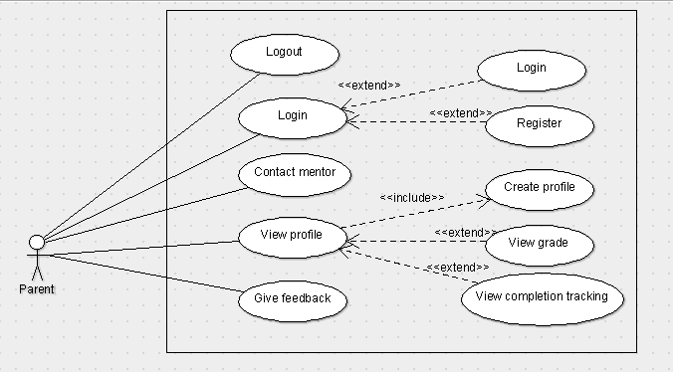

**Figure 3: Use case diagram for Parent module**

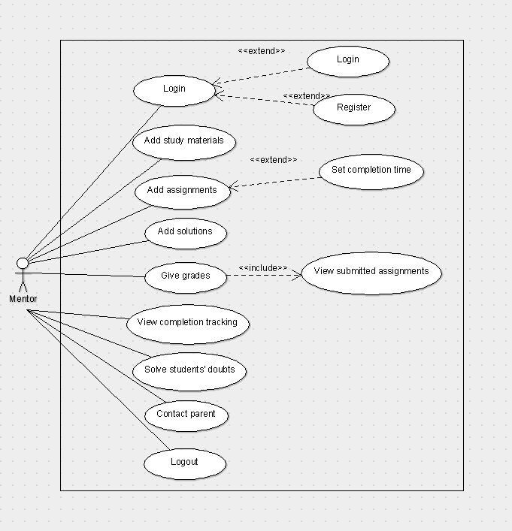

**Figure 4: Use case diagram for Mentor module**

**3.SYSTEM DESIGN**

**3.1 Design Goals**

The application comprises of many features and hence the system is divided into various

components. The main objective of this section is to elaborate the system design and to give an

overview of the various components of the application including their interfaces. It also provides

information about the relationship between the various components and the different data

elements used by each of the components. It also explains the overall system design. The

application has a client-server architecture with the application running on the client side and the

files residing on the server side with which the user interacts through the application. The

following sections contains class diagram, sequence diagram and activity diagrams representing

the various components and their interactions and also the detailed description of each of the components.

**3.2 System Architecture**

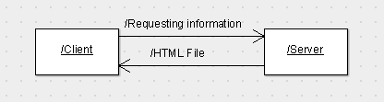

**Figure 5:Client Server architecture**

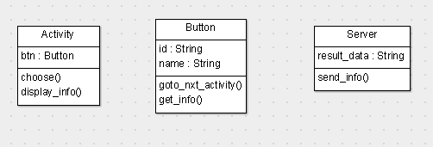

**Figure 6: Class diagram**

Class Name: Activity  
Attributes: Array of Buttons  
Methods: choose() – upon clicking the button the user can choose his/her options  
Display_info()- retrieves and displays information  
  
Class Name: Button  
Attributes: ID - String  
 Name - String  
Methods: go_to_nxt_activity() - upon clicking, it directs to the next activity  
 get__info() - retrieves information from the files

Class Name: Server  
Attributes: Array of files  
Methods: send_info() - send the requested information stored in the files

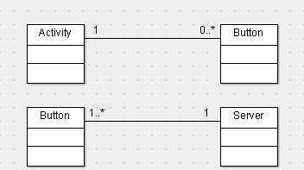

**Figure 7: Association between classes**

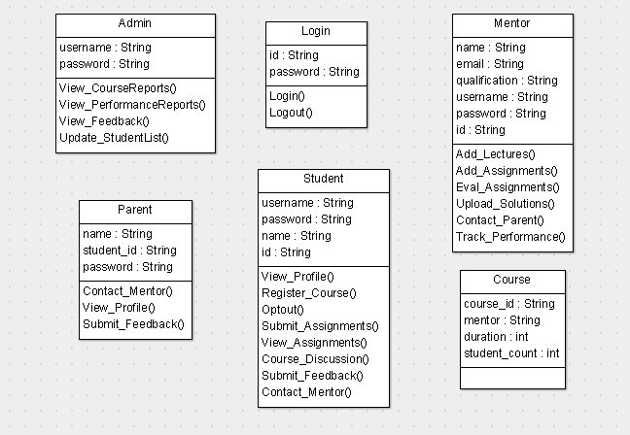

**Figure 8: Description of components**

**3.3 Interaction Diagrams**

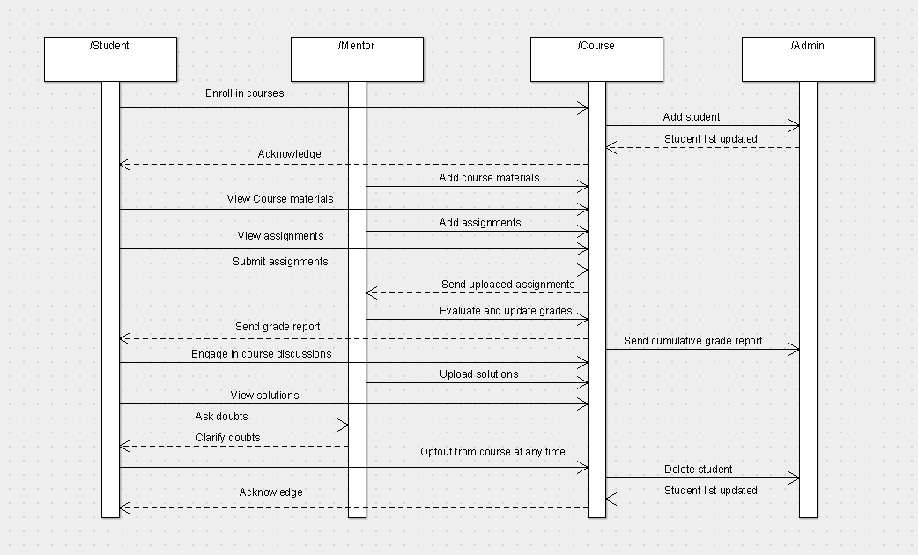

**Figure 9:Sequence diagram for Student activity**

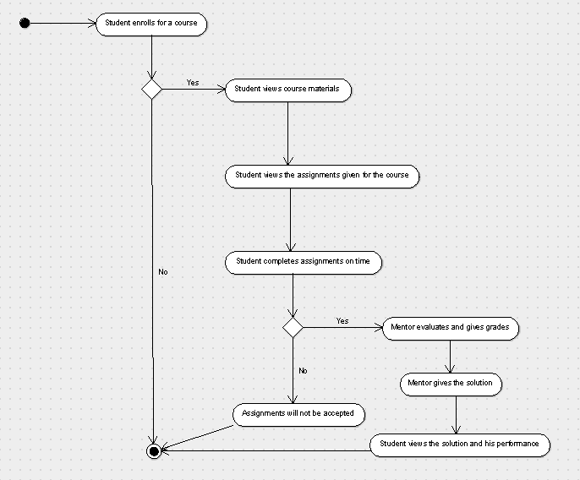

**Figure 10:Activity diagram for Student activity**

**3.4 Detailed Design Methodologies**

**3.5 ER-DIAGRAM**

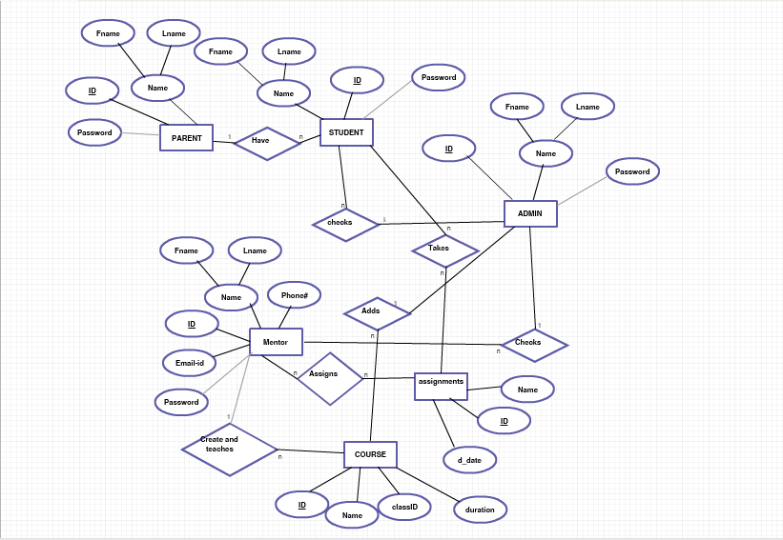

**Figure 11:-ER Diagram for e-LMS**

**4. WORK DONE**

**4.1 Development Environment**

The online e-learning system is an website application and is named as EduLearn.The development process consists of two phases.1.Developing the website Edulearn.2.Extracting,filtering and structuring data.

4.1.1 Developing the website Edulearn

The website has been developed and built using HTML,CSS,Bootstrap,Php and MySQL.The GUI is designed keeping in mind the design rules to make it more user intuitive and universally available and also to attract the users.This will give a clear picture about the courses,registering to courses and submitting the assigm]nments to the student and other actors about their functionalities.The client application will connect to the server files using HTTP Protocol.

4.1.2 Extracting,filtering and structuring data

Once the links have been extracted, the data from the web pages have been extracted using

MySQL queries. The MySQL queries extract data from a given HTML document based on the

specified tag name given. The extraction process has been performed in phpMyAdmin using Mysql to retrieve data from the database.. The data from each of the selected links is extracted and displayed to the user. This is done on theremote Web Server.

**4.2 Testing**

The aim of the system testing process was to determine all defects in our project. The program

was subjected to a set of test inputs and various observations were made and based on these

observations it will be decided whether the program behaves as expected or not.

4.2.1 UNIT TESTING :

Unit testing is undertaken when a module has been created and successfully reviewed .In order

to test a single module we need to provide a complete environment ie besides the module we

would require

• The procedures belonging to other modules that the module under test calls

• Non local data structures that module accesses

• A procedure to call the functions of the module under test with appropriate parameters

Unit testing was done on each and every module that is described under module description of

chapter 4

1.Test For the admin module

Testing admin login form-This form is used for log in of administrator of the system. In this we

enter the username and password if both are correct admin page will open otherwise if any of

data is wrong it will get redirected back to the login page and again ask for username and

password

• Student account addition- In this section the admin can enter student details and then only

view student details from database it contains add button if user click add button data will be

added to student database

• Teacher Addition- Admin can enter details of teacher and can add the details to the main

teacher table also he can view the teacher details

• Course Addition- Admin can enter details of course and can add the details to the main course

table also he can view the teacher details

2.Test for Teacher login module

• Test for Teacher login Form-This form is used for log in of teacher .In this we enter the

username and password if all these are correct teacher home page will open otherwise if any of

data is wrong it will get redirected back to the login page and again ask for username and

password.

3.Test for Parent login module

• Test for parent login Form-This form is used for log in of parent .In this we enter the

username and password if all these are correct parent home page will open otherwise if any of

data is wrong it will get redirected back to the login page and again ask for username and

password.

4.2.2INTEGRATION TESTING :

In this type of testing we test various integration of the project module by providing the input.

The primary objective is to test the module interfaces in order to ensure no errors are occuring when one module invokes the other module.

**4.3 Performance of the website**

**4.4 Cost Estimation of the Website**

**5.CONCLUSION AND FUTURE WORK**

The analysis, design and implementation parts of the Student Profile Management System are

done taking care of many efficiency aspects. The project also passed the testing phase well.

Now there is no more vulnerability to be observed in this. We can directly proceed using this

project for a school in a well-established manner.

EduLearn was successfully developed meeting all the functional and non-functional

requirements that were identified in the initial phase of development. All the features were

implemented and effectively retrieves the required information and displays it to the user based

on the choices made by him/her. All students who wish to learn courses of their choice can use this application to get educated.

As the system includes the basic things like assignments, lecture videos and so on, it fits with every different type of students.. To meet the future requirements and the drastically

increasing digitalization, we can make an android application so that the students can use the

system in phones too. These things are thought of for the improvement of the project

performance and no activity causes degradation of the functionalities. There is a future scope

of this facility that many more features such as online live lecture videos tutorials where

students can ask doubts on the spot, online competitions in different streams, overall rank

board can be added to this project thus making it more interactive more user friendly and

project which fulfills each users need in the best way possible.

**REFERENCES**